Ex.no:3 | DATA CLEANING

Aim:

Algorithm:
Check Missing Values:
- Start.
- Import the pandas library.
- Load the dataset into a DataFrame (df).
- Display dataset information using df.info().
- Check missing values using df.isnull().
- Count missing values using df.isnull().sum().
- Check missing values using df.isna().
- Check non-missing values using df.notnull().
- Display the results.

Drop Missing Values
- Start.
- Import the pandas library.
- Load the dataset into a DataFrame (df).
- Drop missing rows using dropna().
- Drop rows (axis=0) or columns (axis=1).
- Use how='any' to remove rows/columns containing any missing value.
- Use how='all' to remove rows/columns only if all values are missing.
- Use thresh=N to keep rows/columns with at least N non-missing values.
- Use subset=['column_name'] to drop rows based on specific columns.
- Use inplace=True to modify the original DataFrame.
- Display the cleaned DataFrame.

Program:
import pandas as pd
# Load dataset
df = pd.read_csv("hotel_bookings.csv")

print("===== DATASET INFO =====")
df.info()

print("\n===== MISSING VALUES IN EACH COLUMN =====")
print(df.isnull().sum())

print("\n===== TOTAL MISSING VALUES =====")
print(df.isnull().sum().sum())

print("\n===== ANY MISSING VALUES? =====")
print(df.isnull().values.any())

print("\n===== NON-MISSING VALUES COUNT =====")
print(df.notnull().sum())

import pandas as pd

df = pd.read_csv("hotel_bookings.csv")

# Fill all missing values with 0
df_constant = df.fillna(0)
print("===== CONSTANT VALUE =====")
print(df_constant.head())

# Fill 'children' column with mean
df_mean = df.copy()
df_mean["children"] = df_mean["children"].fillna(df_mean["children"].mean())
print("\n===== MEAN =====")
print(df_mean.head())

# Fill 'children' column with median
df_median = df.copy()
df_median["children"] = df_median["children"].fillna(df_median["children"].median())
print("\n===== MEDIAN =====")
print(df_median.head())

# Fill 'country' column with mode
df_mode = df.copy()
df_mode["country"] = df_mode["country"].fillna(df_mode["country"].mode()[0])
print("\n===== MODE =====")
print(df_mode.head())

# Forward Fill
df_ffill = df.ffill()
print("\n===== FORWARD FILL =====")
print(df_ffill.head())

# Backward Fill
df_bfill = df.bfill()
print("\n===== BACKWARD FILL =====")
print(df_bfill.head())
import pandas as pd

df = pd.read_csv("hotel_bookings.csv")

# Drop rows with missing values
df_drop_rows = df.dropna()
print("===== DROP ROWS =====")
print(df_drop_rows.head())

# Drop columns with missing values
df_drop_cols = df.dropna(axis=1)
print("\n===== DROP COLUMNS =====")
print(df_drop_cols.head())

# Drop rows having any missing value
df_any = df.dropna(how="any")
print("\n===== DROP HOW='ANY' =====")
print(df_any.head())

# Drop rows where all values are missing
df_all = df.dropna(how="all")
print("\n===== DROP HOW='ALL' =====")
print(df_all.head())

# Keep rows with at least 30 non-null values (32 columns total)
df_thresh = df.dropna(thresh=30)
print("\n===== THRESH=30 =====")
print(df_thresh.head())

# Drop rows where 'country' or 'children' is missing
df_subset = df.dropna(subset=["country", "children"])
print("\n===== SUBSET (country, children) =====")
print(df_subset.head())

# Drop missing values permanently
df.dropna(inplace=True)
print("\n===== AFTER inplace=True =====")
print(df.head())
Output:

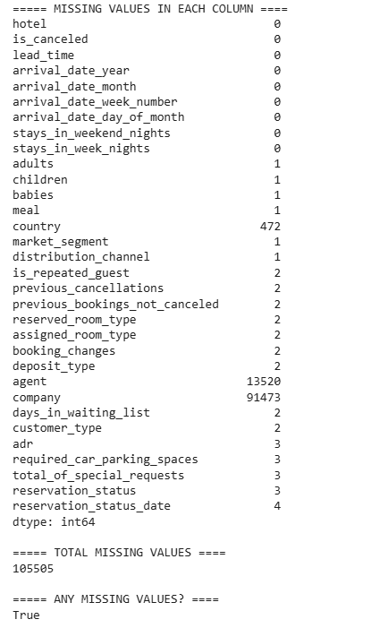
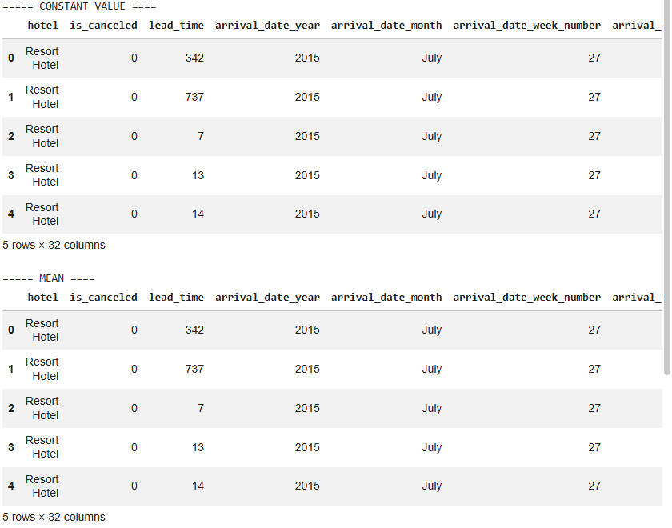
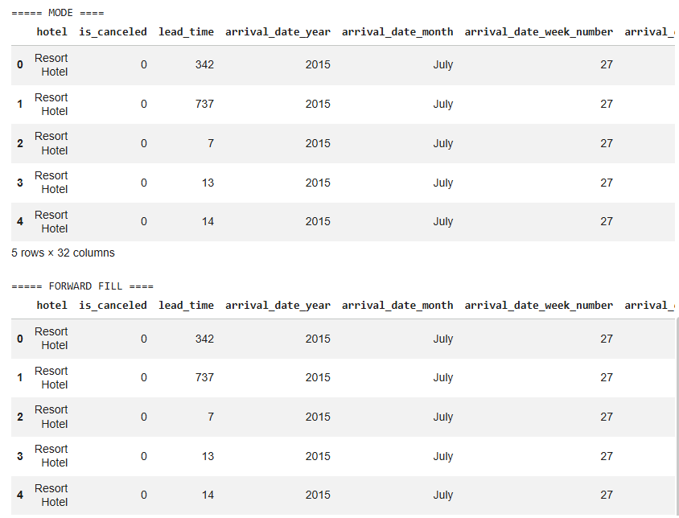

Result:

